FREEDOM RIDERS
- In 1965, a group of university students, including Aboriginal student Charlies Perkins, hired a bus and went out to western New South Wales to show Australia and the world that racism still existed in these towns.
- They wanted to expose the apartheid (separating people of different races, segregation) policies of country towns where Aboriginals were forced to live apart from the white population and forbidden to enter public places such as pubs, swimming pools and picture theatres.
- The Reverend Ted Noffs of the Wayside Chapel in Kings Cross helped organise the rides, raised money and was the city contact for both the media and the students.
- They were inspired by the freedom rides that civil liberties activists in the southern states of America organised to protest at the treatment of Black Americans.
- The bus travelled through the towns of Orange, Wellington, Gilgandra, Gulargambone, Walgett, Moree, Boggabilla, Tenterfield, Lismore, Grafton, Bowraville, Kempsey and Taree.
- They demonstrated outside the Returned Services League (RSL) in Walgett because it denied Aboriginal ex-servicemen membership.
- They also demonstrated outside Moree’s swimming pool, where Aboriginals were denied entry.
- They completed the trip in two weeks, staying in most places for only a day, but this was still long enough to reveal the prejudice and discrimination that local Aboriginal people in these towns lived with every day.
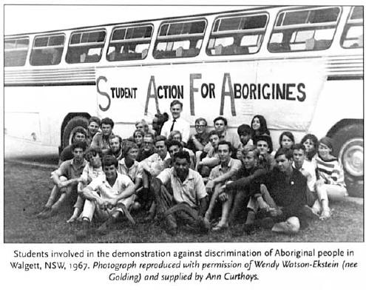
RESEARCH TASK – Freedom Riders
http://indigenousrights.net.au/section.asp?sID=33
- In your workbooks read the information on the above website and record the most important points under the headings:
  - Hatching the idea
_________________________________________________________________________________________________________________________________________________________________________________________________________________________________________________________________________________________________________________
  - Where the Freedom Ride went
____________________________________________________________________________________________________________________________________________________________________________________________________________________________________________________
_____________________________________________________________

  - Responses to the Ride
____________________________________________________________________________________________________________________________________________________________________________________________________________________________________________________
  - Aftermath
_____________________________________________________________________________________________________________________

FREEDOM RIDERS

WHAT: _______________________________________________________________________________________________________________________________________________________________________________________

WHO: _______________________________________________________________________________________________________________________________________________________________________________________

WHEN: _______________________________________________________________________________________________________________________________________________________________________________________

WHERE: ____________________________________________________________________________________________________________________________________________________________________________________________________________________________________________________

WHY / PURPOSE: ______________________________________________________________________________________________________________________________________________________________________________________________________________________________________________________________________________________________________________________________________________________________________________

OUTCOME / EFFECT: ______________________________________________________________________________________________________________________________________________________________________________________________________________________________________________________________________________________________________________________________________________________________________________

SUMMARY OF KEY EVENT: ___________________________________________________________________________________________________________________________________________________________________________________________________________________________________________________
Additional links : Hidden Heroes of Australian History

