Mabo and Native Title

Mabo and Others v. The State of Queensland (1992)
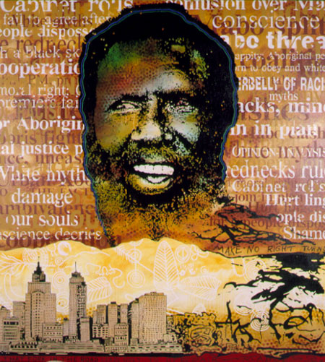
- In the late 1970’s the government tried to deny some of the Meriam Islanders the use of their lands.
- The Meriam Islanders have lived on their land since ‘time immemorial”.
- Eddie Koiki Mabo challenged the governments right to do this
- After losing their case in the Qld Supreme Court, they appealed to the High Court of Australia
- On 3 June 1992, the High Court decided in favour of the Meriam Islanders - that native title had existed before 1788 and continued to exist as they had continuously lived there.
- If land had been legally granted or sold by governments to someone else then native title ceased to exist.
- Native Title = the legal recognition of the existence of indigenous people’s law and land ownership before 1788
- Land rights differ from native title rights in that they are linked to claims people make to governments to be recognised as the legal owners of a particular area.
- Mabo overturned the legal fiction of terra nullius (‘land belonging to no-one’)

Source: National Archives of Australia
Significance
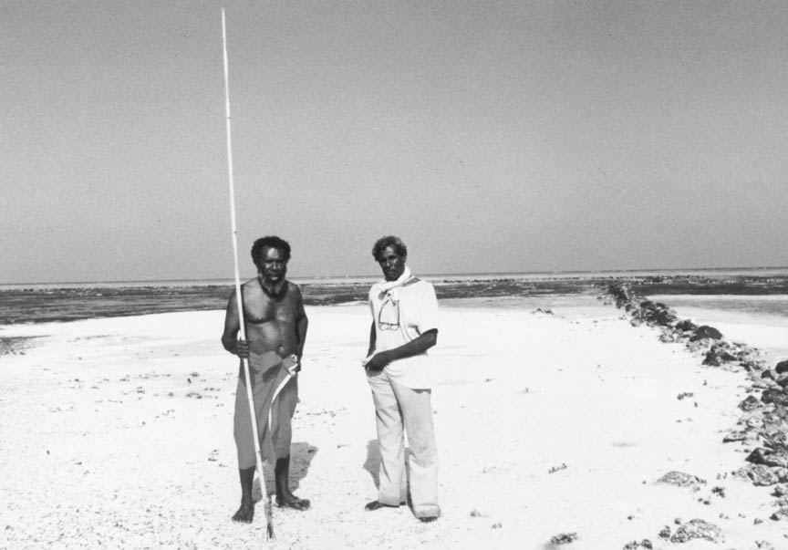
The judgments of the High Court in the Mabo case inserted the legal doctrine of native title into Australian law. In recognising the traditional rights of the Meriam people to their islands in the eastern Torres Strait, the Court also held that native title existed for all Indigenous people in Australia prior to Cook's Instructions and the establishment of the British Colony of New South Wales in 1788. This decision altered the foundation of land law in Australia.
The new doctrine of native title replaced a 17th century doctrine of terra nullius (no-one's land) on which British claims to possession of Australia were based. The Mabo decision thus solved the problem posed by the Gove Land Rights Case in 1971, which followed the 'legal fiction' of terra nullius.
In recognising that Indigenous people in Australia had a prior title to land taken by the Crown since Cook's declaration of possession in 1770, the Court held that this title exists today in any portion of land where it has not legally been extinguished.

MABO AND NATIVE TITLE
Use the following link and the sheet provided to complete the summary points below. Hidden Heroes of Australian History

WHAT: _______________________________________________________________________________________________________________________________________________________________________________________

WHO: _______________________________________________________________________________________________________________________________________________________________________________________

WHEN: _______________________________________________________________________________________________________________________________________________________________________________________

WHERE: ____________________________________________________________________________________________________________________________________________________________________________________________________________________________________________________

WHY / PURPOSE: ______________________________________________________________________________________________________________________________________________________________________________________________________________________________________________________________________________________________________________________________________________________________________________

OUTCOME / EFFECT: ______________________________________________________________________________________________________________________________________________________________________________________________________________________________________________________________________________________________________________________________________________________________________________

SUMMARY OF KEY EVENT: ___________________________________________________________________________________________________________________________________________________________________________________________________________________________________________________

