Web quest: Changing Rights and Freedoms:
First Australians and the 1967 referendum

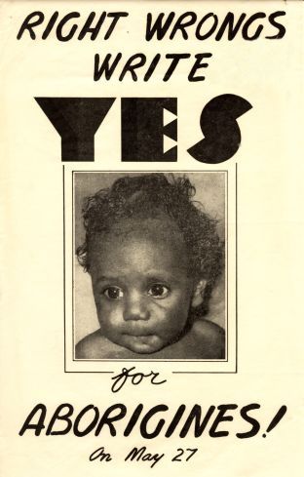
INTRODUCTION
The 1967 Referendum was a significant milestone in the progress towards equal rights for Indigenous Australians. This web quest analyses the importance of the referendum in the struggle for civil rights and recognition and whether the themes associated with it are still prevalent today.
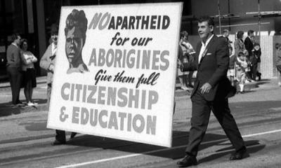
In the period of Australia's history following the Second World War most Australians thought they lived in a fair and just democracy. It was thought that there were no class distinctions such as in Britain or the racial tensions which were becoming more prevalent in the United States and South Africa. The indigenous minority felt very different. Having lost their land and livelihood to European settlers and the Australian government many were left homeless living in 'humpies' on the edge of town or in reservations and missions. There were restrictions on where they could live and who they could marry. They were often not the legal guardians of their own children, local policemen controlled their earnings and in some states local mission managers could even open and censor their mail.
The majority either didn't know or care about the sufferings of the minority. From the late 1950s and through the 1960s many became aware of the disadvantage and began a largely grass roots campaign to bring civil rights and greater recognition to First Australians. This cumulated in 1967 with a referendum to change the Australian Constitution.

