The response to the threat of communism within Australia including:
- referendum to ban the Communist Party
- the Petrov Affair

Students learn to:
- outline the key developments in Australia’s response to communism within Australia

Referendum to ban the Communist Party
Make notes on the following:
- The party and prime minister in power from 1949
- Why the government feared Communism
- The Communist Party Dissolution Bill
- The High Court challenge to the bill
- The subsequent referendum: what it attempted to do; whether it was successful.
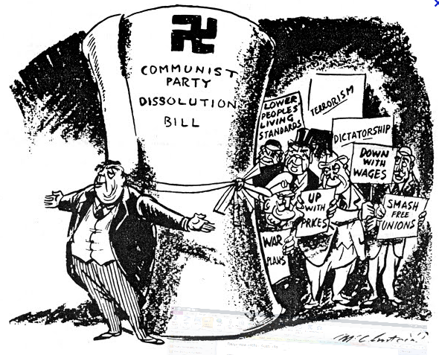 | 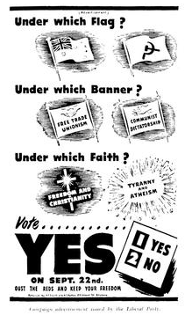 | 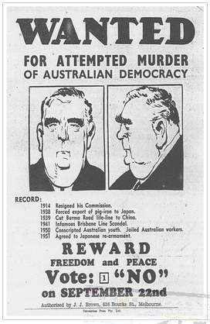
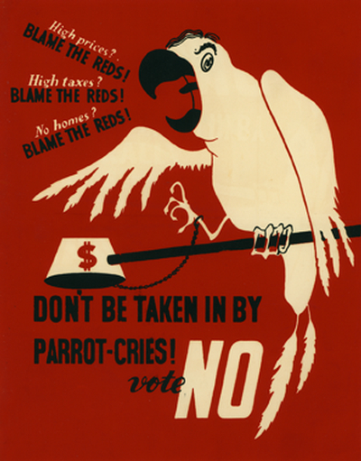 | 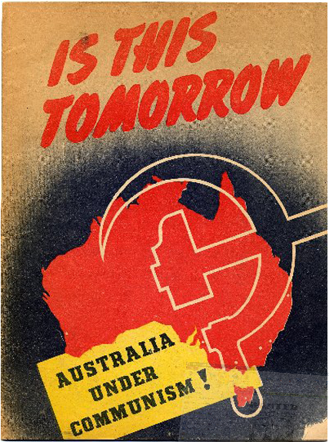 | 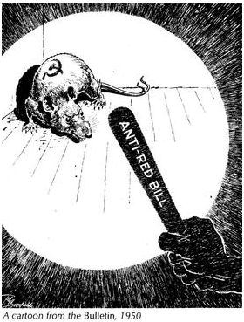

Explain each of the above sources and relate to the attempts to ban the Communist Party.
- What is the perspective of the source?
- What is the purpose of the source?
- What is depicted in the source? (explain people, images, symbols, text)

