Web quest: Changing Rights and Freedoms:

First Australians and the 1967 referendum

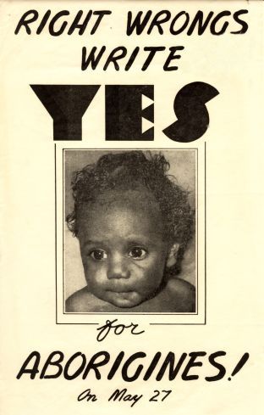

INTRODUCTION

The 1967 Referendum was a significant milestone in the progress towards equal rights for Indigenous Australians. This web quest analyses the importance of the referendum in the struggle for civil rights and recognition and whether the themes associated with it are still prevalent today.

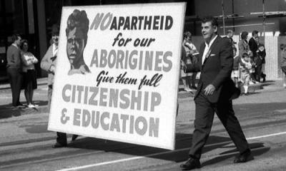

In the period of Australia's history following the Second World War most Australians thought they lived in a fair and just democracy. It was thought that there were no class distinctions such as in Britain or the racial tensions which were becoming more prevalent in the United States and South Africa. The indigenous minority felt very different. Having lost their land and livelihood to European settlers and the Australian government many were left homeless living in 'humpies' on the edge of town or in reservations and missions. There were restrictions on where they could live and who they could marry. They were often not the legal guardians of their own children, local policemen controlled their earnings and in some states local mission managers could even open and censor their mail.    
  
The majority either didn't know or care about the sufferings of the minority. From the late 1950s and through the 1960s many became aware of the disadvantage and began a largely grass roots campaign to bring civil rights and greater recognition to First Australians. This cumulated in 1967 with a referendum to change the Australian Constitution.

|  |  |  |  |  |
| --- | --- | --- | --- | --- |
| |  |  |  |  | | --- | --- | --- | --- | | **The scenario:**   You and the other members of your group have travelled back in time to just before the 1967 referendum on Indigenous Rights and Freedom. You have then been invited to a community meeting which plans to discuss the referendum.   **Your task:** The task is divided into a group task and an individual task. Read all the instruction before commencing your work.  **Group task:**  You are to split into three groups, each group is to plan a presentation for the community meeting on one of the following topics concerning the referendum:   Group 1: What is a referendum, and specifically what is the 1967 referendum about, what will it change?  Group 2: Why the referendum is important to Australia and in particular Indigenous Australians?  Group 3: With your knowledge of the future, what was the impact of the referendum on Australia and in particular Indigenous Australians?  Your presentation can take a variety of forms including but not limited to a speech, a slide show or a multimedia presentation. (Fortunately, your time machine is stocked with this equipment)  Each group will need to provide a copy of their presentation to other groups before commencing the individual task.  **Individual Task:** The Australian Green Party Policy platform includes holding a referendum to:  - Amend the preamble of the Constitution to recognise the Aboriginal and Torres Strait Islander peoples as the original and ongoing residents of Australia and their rights as such   - Amend the preamble to the Constitution to recognise the prior occupation and sovereignty of Aboriginal and Torres Strait Islanders as the traditional owners of the land   Both the Labor and Liberal Parties have both proposed support in principle to this policy.  YOUR TASK:  Write a one page letter to the Prime Minister arguing why the referendum proposed by the Australian Greens is a good or bad idea. In framing your argument you are to draw reference to the 1978 referendum, its importance and its impact.  RESEARCH  Once it has been decided which question you group will respond to in the presentation it is time to get down to some research. Scroll down and read the entire page before commencing your work.   **Group 1:**  Research what Australian’s referendums are and what they do. Then, the group will need to research the 1967 referendum specifically and inform the group what changes will occur if they vote ‘yes’ or ‘no’. The following web links provide resources to help with the research.   <http://parlinfo.aph.gov.au/parlInfo/search/display/display.w3p;db=HANDBOOK;id=handbook%2Fnewhandbook%2F2008-12-19%2F0063;query=Id%3A%22handbook%2Fnewhandbook%2F2008-12-19%2F0000%22>Download the PDF Part 5 Referendums and Plebiscites  <http://australianpolitics.com/constitution/>  <http://www.aec.gov.au/pdf/education/resources/history_indigenous_vote.pdf>  <http://www.creativespirits.info/aboriginalculture/history/referendum-1967.html>  **Group 2:**  Leading into the 1967 referendum there were many groups and individuals that made presentation relating to the referendum. The following sites provide links to these sources and information on the campaign which can be used to help in the creation of your presentation.  <http://www.abc.net.au/archives/sales/1967.htm>  <http://www.indigenousrights.net.au/subsection.asp?ssID=28>  <http://www.library.uq.edu.au/fryer/1967_referendum/campaign3.html>(page down for info)  <http://www.australianbiography.gov.au/subjects/bandler/>  **Group 3:**  Research speeches and presentations given since the 1967 referendum. They will also need to analyse current statistics on the health, wealth fare, education, life expectancy etc. to help them answer questions about whether greater rights and freedoms lead to equality.   <http://www.reconcile.org.au/playyourpart/uploads/word/108_051207_1.pdf>  <http://www.hreoc.gov.au/about/media/speeches/social_justice/2007/20071127multiculturalism_position_paper.html>  <http://www.abs.gov.au/ausstats/abs@.nsf/mf/4704.0/>  Your presentation can take a variety of forms including but not limited to a speech, a slide show or a multimedia presentation. (Fortunately, your time machine is stocked with this equipment)  **Part 2: Individual Task**  The following web links will provide information on the Australian Greens policy and to the proposed referendum. Use them to help write your letter to the Prime Minister. Remember to link you argument to the 1967 referendum.  <http://greens.org.au/policies/human-rights-democracy/constitutional-reform-and-democracy>  <http://www.smh.com.au/opinion/society-and-culture/indigenous-inclusion-is-good-for-our-constitution-20100708-10275.html>  <http://www.theaustralian.com.au/national-affairs/coalition-to-put-aboriginal-recognition-to-referendum/story-fn59niix-1225903189578>       |  |  |  | | --- | --- | --- | | |  | | --- | |  | | The 1967 Referendum is seen as an important moment in the struggle for Aboriginal Rights and Freedoms. Researching the campaign leading into the referendum arms you with the knowledge to better understand the challenges and disadvantages many Ingenious Australians have experience. This knowledge can be used to understand the current disadvantages that exist in many Aboriginal communities as well as the political issues that arise when discussed by politicians. To find out more and become more involved visit the following website: <http://www.reconciliation.org.au/> | | | |